Application for Pupil Roles
We are seeking…
Playground Buddies 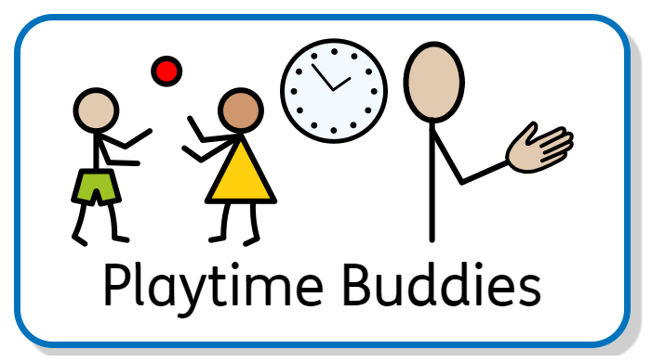
When: Daily  Playtimes and lunchtimes | Where:  Playground/Field
Knowledge required:  - Good understanding of the Academy’s pro social approach.  - Empathy and kindness  - Range of playground games.  - Good conflict resolution skills.  - Energetic.  - Positive attitude. | Benefits:  - Special cap  - Working in the fresh air.  - Interacting with a range of year groups  - Being part of creating a happy school.  - Have fun!
Pupil Application Form

Name: | Date:
Class: | Year Group:
Explain why you would be suitable for this pupil role:

Please email completed forms to the office@robsackwoodprimaryacademy.org.uk

