Application for Pupil Roles
We are seeking
Reading Buddies 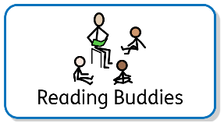
When: tbc | Where: tbc
Knowledge required:  - Enthusiasm for reading  - Good communication skills  - Empathy and patience  - Good at storytelling | Benefits:  - Spend more time reading great books  - Making others happy.  - Improving the love of books in others  - Access to new books  - Improve yours and others wellbeing  - Sparkly badge
Pupil Application Form

Name: | Date:
Class: | Year Group:
Explain why you would be suitable for this pupil role:

Please email completed forms to the office@robsackwoodprimaryacademy.org.uk

