Application for Pupil Roles
We are seeking…
Lunchtime Monitors 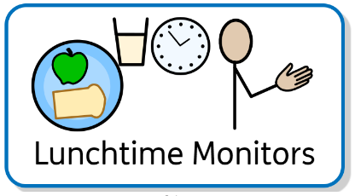
When:  Lunchtime | Where:  Main Hall
Knowledge required:  - Good organisational skills  - Good understanding of the academy’s pro social approach.  - A healthy attitude to food.  - Have good social skills and ability to interact with all year groups.  - Able to support cleaning  - Tidy and clean person | Benefits:  - Extra puddings!  - Helping teachers  - Sparkly badge
Pupil Application Form

Name: | Date:
Class: | Year Group:
Explain why you would be suitable for this pupil role:

Please email completed forms to the office@robsackwoodprimaryacademy.org.uk

